# Week 3 Queries and Results

1. SELECT DISTINCT(CONCAT(employee_info.First_Name,' ',employee_info.Last_Name)) AS 'Employee Name', employee_info.Manager_ID

FROM employee_info,branches

ORDER BY employee_info.Manager_ID;

Result:

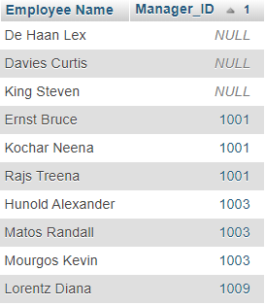

1. SELECT employee_info.Last_Name

FROM employee_info

WHERE employee_info.Last_Name LIKE '%a%' OR '%e%' ;

Results:

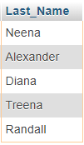

1. SELECT electronics.Item_Name

FROM electronics

WHERE electronics.Item_Price >= 50000;

Results:

